**Online Examination System Guide (WEB BASED)**



**USER MANUAL**

***Project by:-***

**Piyush .V. Khadse**

**Adway .S. Kirwe**

**Pranav .S. Deshpande**

**Mayur .S. Padma**

**Nitin .R. Naik**

***Guided By:-***

**Prof. Mr M. M. Goswami**

**Overview of Online Examination System:**

The Online Examination System is easy to use, full-featured and flexible Testing, Examination and Assessment web portal. It allows Administrators to set different examination and question banks for registered students and members. The examination System provides complete functionality of evaluating and assessing student's performance skills. The examination System comprises of Question Bank effectively blended with a whole set of Features. Using different features of the Examination System an administrator can set an exam name, select an examination, and assign questions for examination. The question bank will form the backbone of the automated process and will play an important role in random generation of unique sets of question papers. The more the number of questions the better randomization is achieved.

* Requirements for OES (Online Examination System):

**Server Side Requirements:-**

1. **Hardware Requirements:**

Hardware recommended by all the software needed.

* + Communication hardware to serve client requests
  + 1GB of RAM
  + ROM 20GB (Minimum Recommended)

1. **Server side software:**
   * + - Web server software( Apache)
       - Server side scripting tools: PHP
       - Database tools: MySQL, XML DBMS.
       - Compatible operating system: Windows
       - USBWebserver (Consist of all above components configured automatically).
       - Web Browser (Mozilla Firefox-Recommended).
       - Sublime Text 2 for PHP and XML coding.

* **ABOUT USBWEBSERVER:**

USBWebserver is a combination of the popular webserver software: Apache, MySQL, Php and PhpMyAdmin. With USBWebserver it is possible to develop and show your php websites, everywhere and anytime the advantage of USBWebserver is, you can use it from USB of even CD

USBWebserver is perfect for:

* Show a offline version of your website
* Anywhere develop php websites
* No need for expensive hosting
* Working at multiple locations at projects

**Xampp Server Configuration**:

**In your web browser, go to http://www.apachefriends.org/en/xampp-windows.html**

2. **Click on the download link for XAMPP.**

[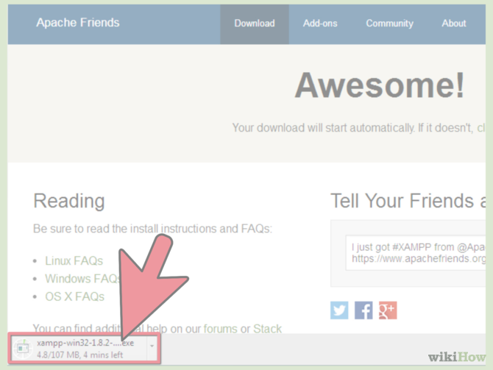](http://www.wikihow.com/Install-XAMPP-for-Windows#/Image:Install-XAMPP-for-Windows-Step-3.png)

3. **When prompted for the download, click "Save" and wait for your download to finish.**

[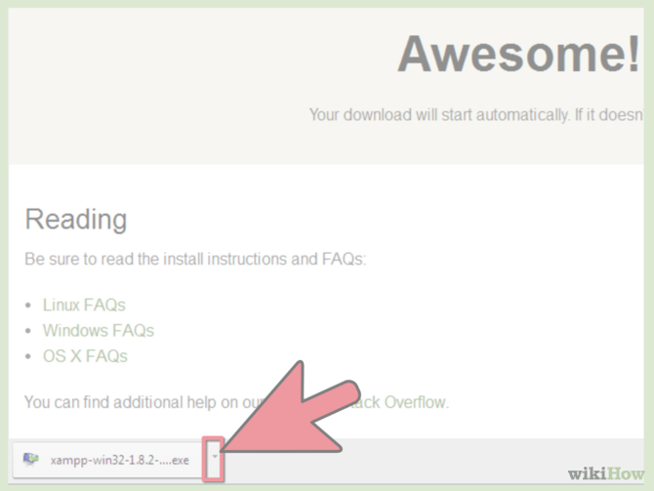](http://www.wikihow.com/Install-XAMPP-for-Windows#/Image:Install-XAMPP-for-Windows-Step-4.png)

4. **Once your download is complete, install the program, click on "Run"**

[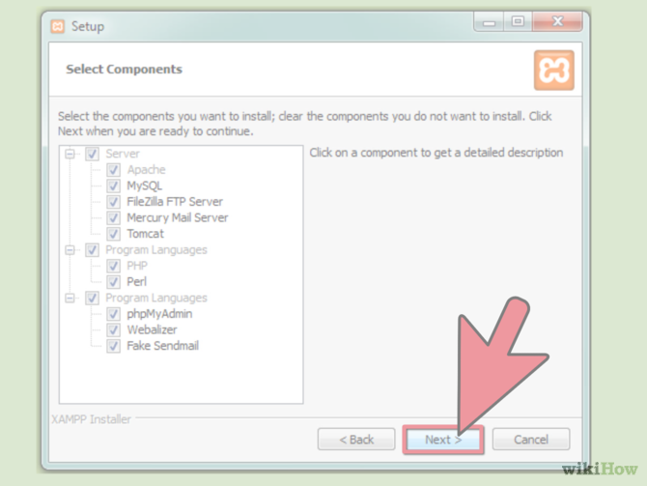](http://www.wikihow.com/Install-XAMPP-for-Windows#/Image:Install-XAMPP-for-Windows-Step-5.png)

5. **Accept the default settings.** A command will open and offer an initial installation prompt. Just hit the Enter key, and accept the default settings. To simplify installation, just hit ENTER when prompted on the command line. You can always change settings, by editing the configuration files later.

[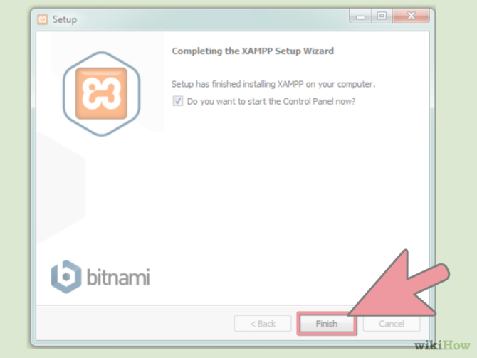](http://www.wikihow.com/Install-XAMPP-for-Windows#/Image:Install-XAMPP-for-Windows-Step-6.png)

6. **When your installation is complete, exit the command window by typing x on the command line.**

[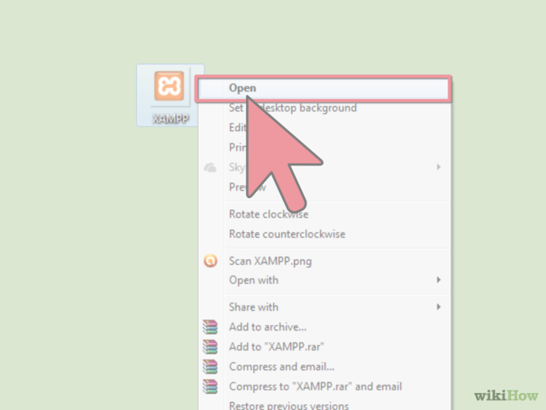](http://www.wikihow.com/Install-XAMPP-for-Windows#/Image:Install-XAMPP-for-Windows-Step-7.png)

7. **Start the XAMPP Control Panel.**

[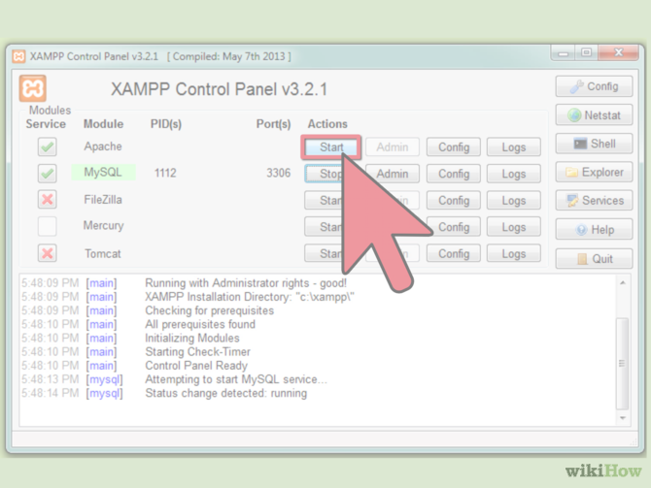](http://www.wikihow.com/Install-XAMPP-for-Windows#/Image:Install-XAMPP-for-Windows-Step-8.png)

8. **Start the Apache and MySQL components.** You can also start the other components, if you plan to use them.

[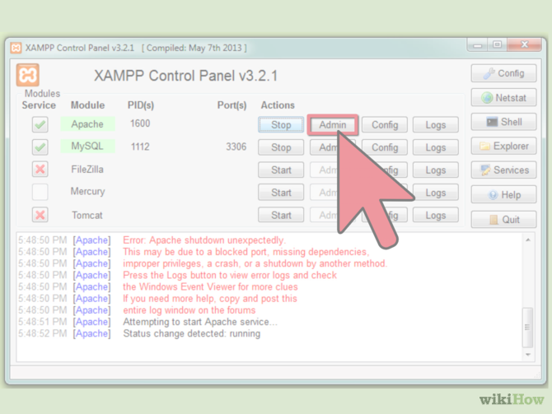](http://www.wikihow.com/Install-XAMPP-for-Windows#/Image:Install-XAMPP-for-Windows-Step-9.png)

9. **Verify the Apache install, by clicking on the Apache administrative link in the Control Panel.**

[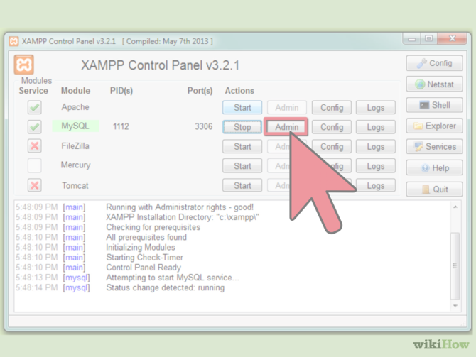](http://www.wikihow.com/Install-XAMPP-for-Windows#/Image:Install-XAMPP-for-Windows-Step-10.png)

10. **Verify the MySQL installation, by clicking on the MySQL administrative link in the XAMPP Control Panel.**

* If the verification steps are successful, XAMPP should be successfully installed on your PC. Open a browser and enter "localhost" on your address bar. You will be redirected to a page telling you that you've successfully installed xampp on your syste

**Accessing the EXAMINATION:**

* **SERVER ACCESS:**
  1. Type the local machine’s I/P address i.e. LOCALHOST or simply run usbwebserver.exe and CLICK on LOCALHOST.
  2. localhost:8080/project/adminlog.php (Press Enter).
  3. Enter Username, Password to gain access (Recommended for Faculty).
  4. Set the type of EXAMINATION to be conducted by selecting the appropriate combination.
  5. CLICK START EXAM BUTTON.
  6. On time completion CLICK STOP BUTTON.
* **CLIENT ACCESS:**

1. Enter the appropriate I/P address of the server in address bar of browser.(Press Enter)
2. Enter the ROLL NUMBER in the text box. (Not eligible if not registered for course).
3. Next page displays the details CLICK on START to begin the test.
4. On completion click END EXAM. Result will be declared there itself.

* **RESULT GENERATION:**
  + 1. Result generation will be at the SERVER END where user can access his result and verify the answers (Faculty Permissions Required).
    2. No change in result will be accepted as the result is COMPUTER GENERATED.
* **DATABASE SETUP:**
  1. Set the examination to be conducted from the “PHYSICS”||”CHEMISTRY Database.
  2. Select the PROGRAMME for which the examination is conducted eg:-Automobile Engineering (AE) which loads the (AE) PROGRAMME database into the memory.
  3. Keep a check on the LOGGED IN and LOGGED OUT candidates through DETAILS PANE on Server .Candidates status are stored in DB till exam in not “ENDED” by faculty.
  4. Results database permanently stores the results of each student of EACH PROGRAMME.

**Admin’s Panel**

1. Log In with appropriate details.

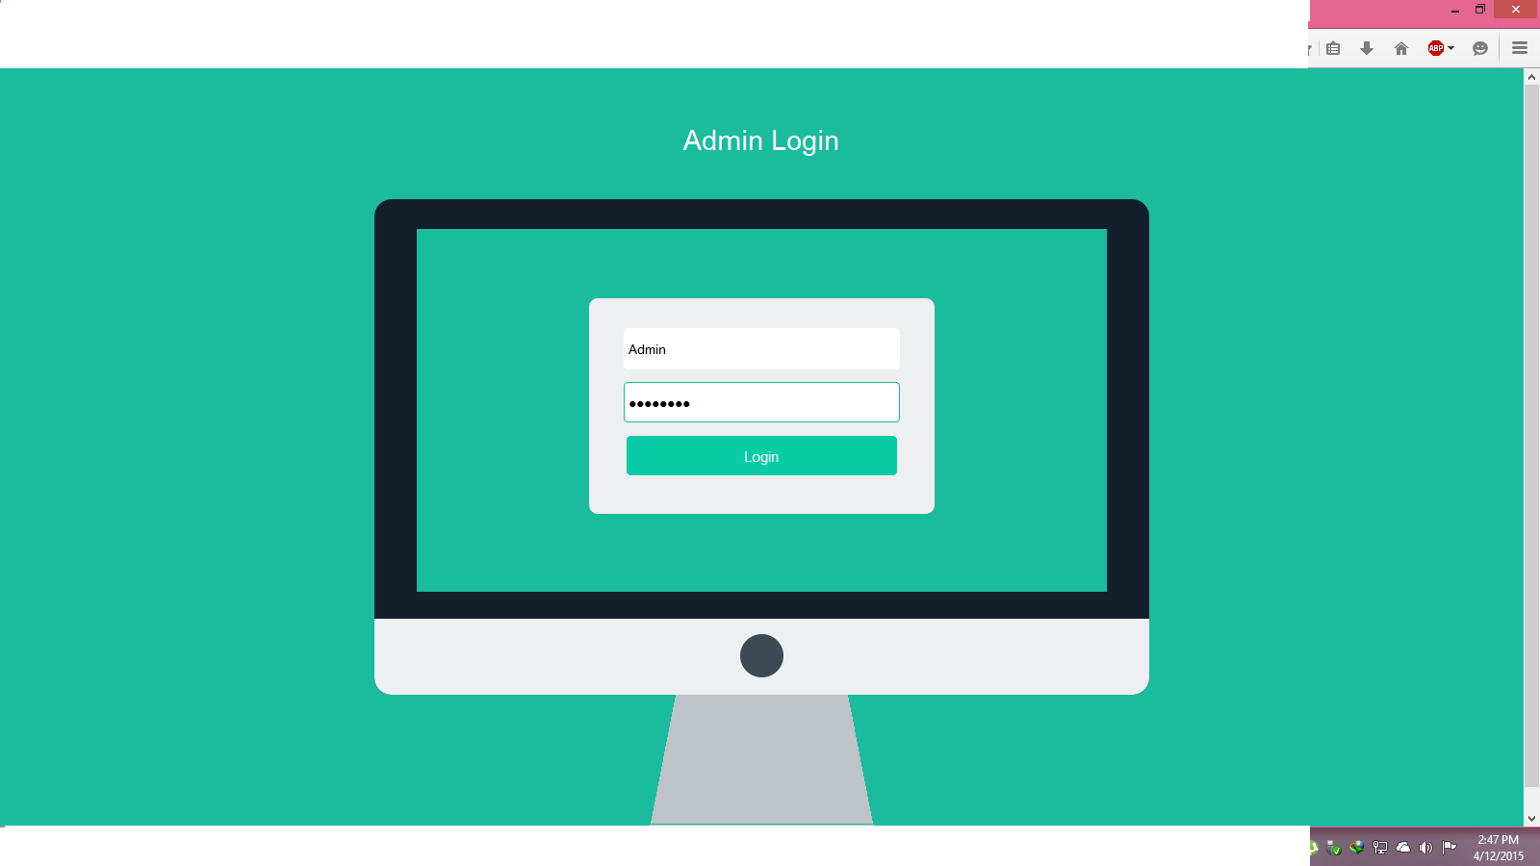

1. Home Page for ADMIN PANEL (Click on exam to set EXAMINATION).

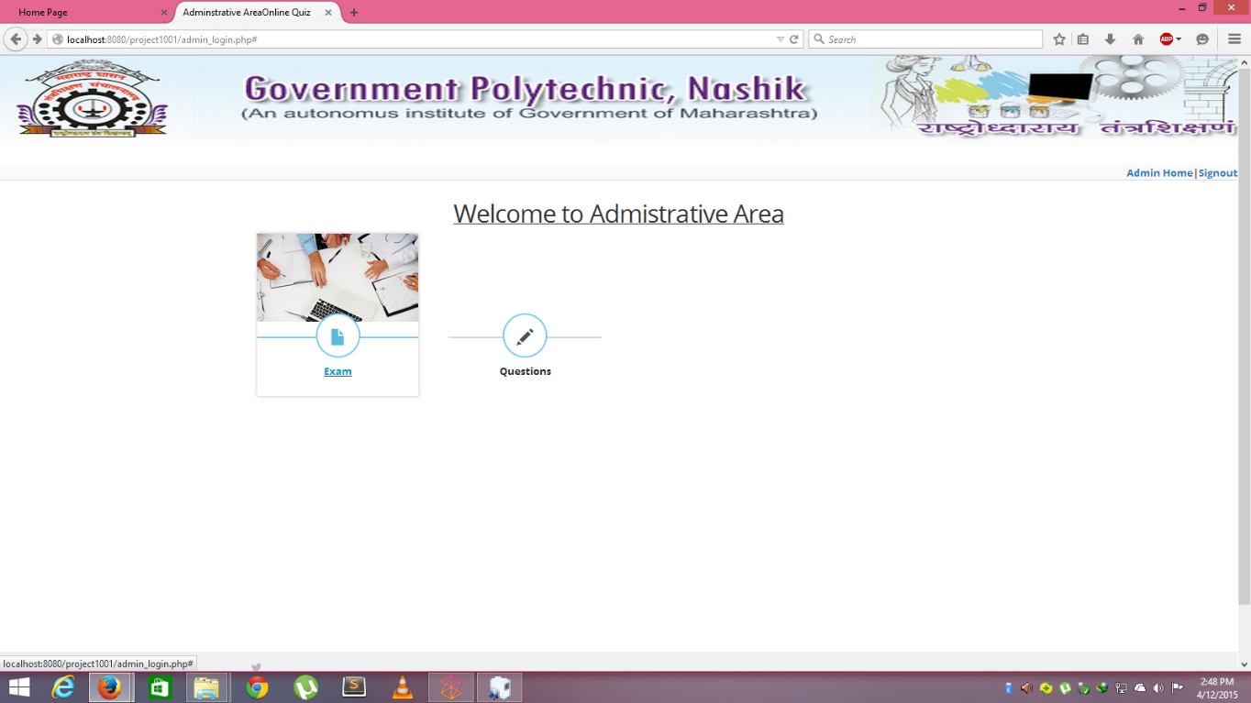

1. Various TABS for Exam details (START EXAM to set a TEST).

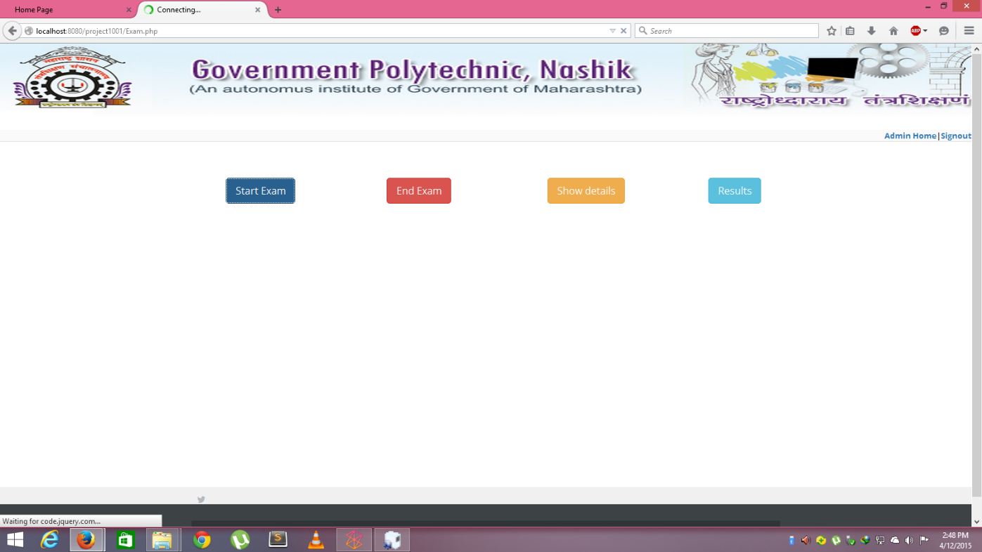

1. EXAM SETTING Panel for Administrators and Faculty.

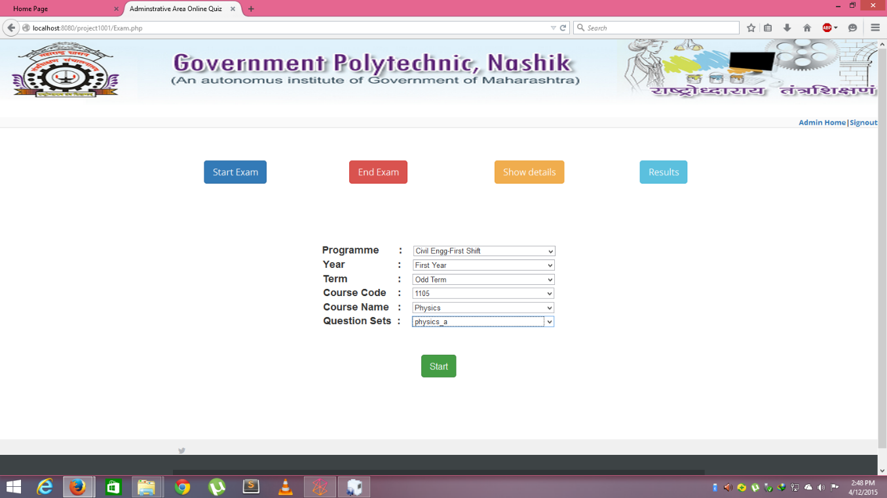

1. The status of CURRENT EXAM CANDIDATES (True->Logged-In , False->Logged-Out).

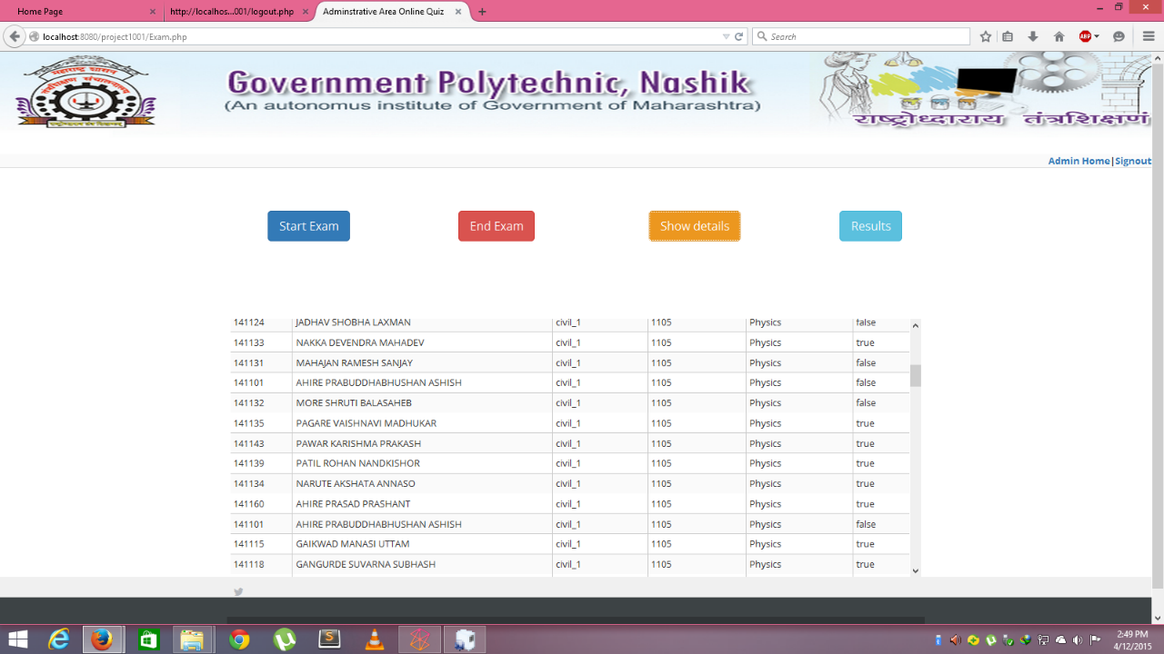

5. Result sheet of latest appeared batch and details.

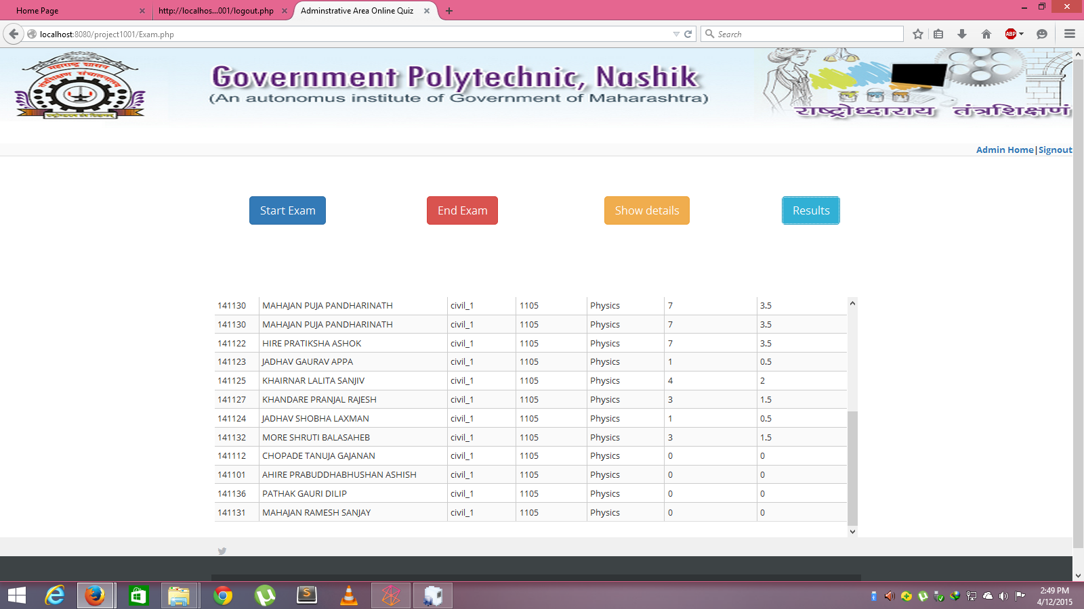

1. EXAMINATION End status.

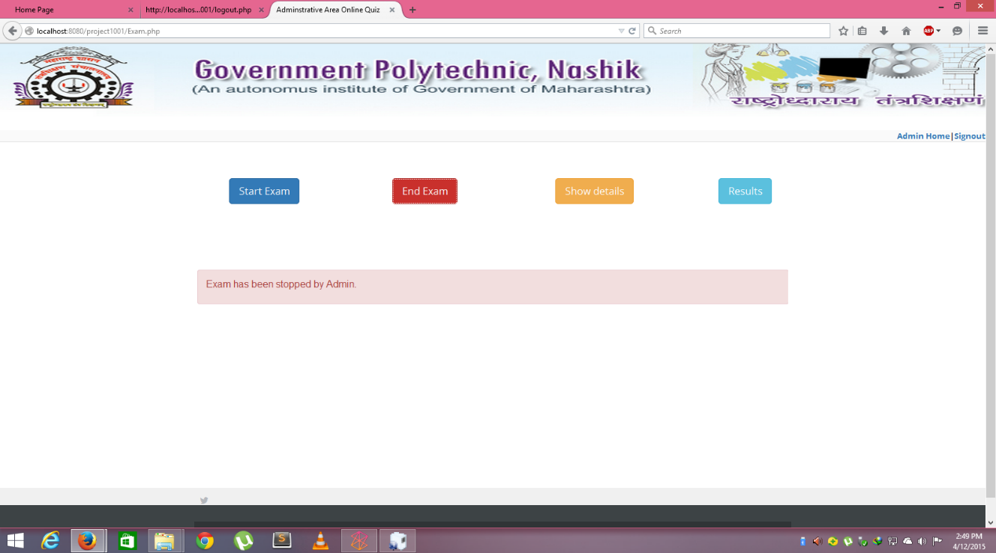

**Client (Candidate’s) Panel**

1. Click on HOME to obtain Log-In page

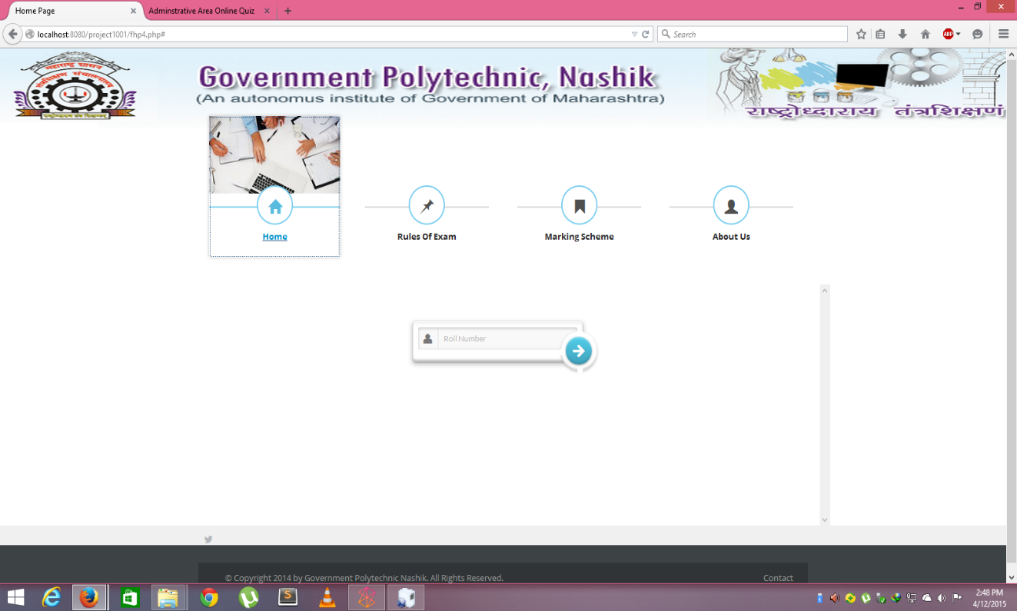

1. Login Pane for Students to Log-In.

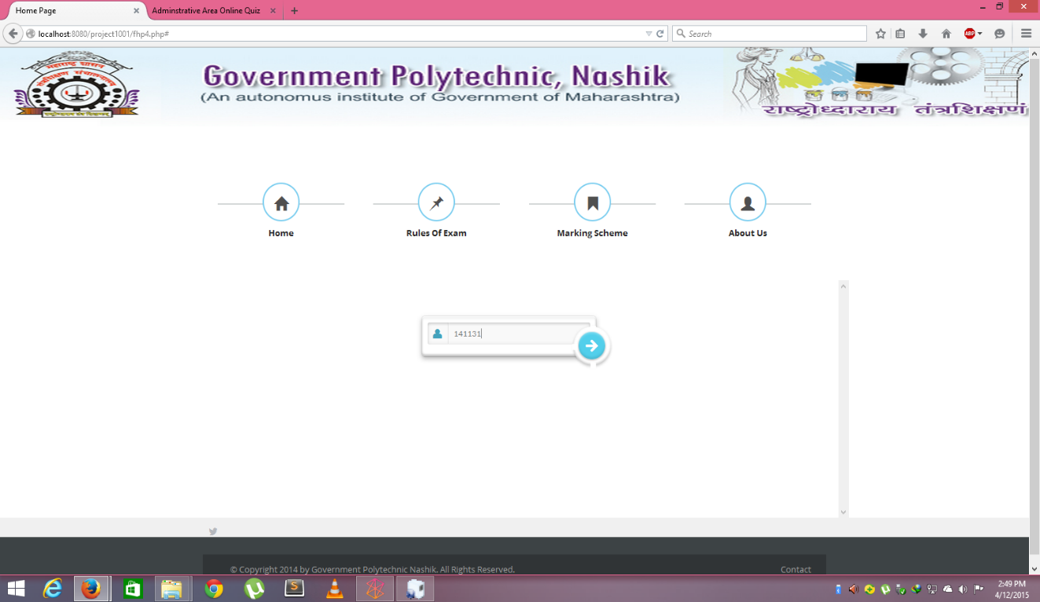

1. Verification of Student’s Det

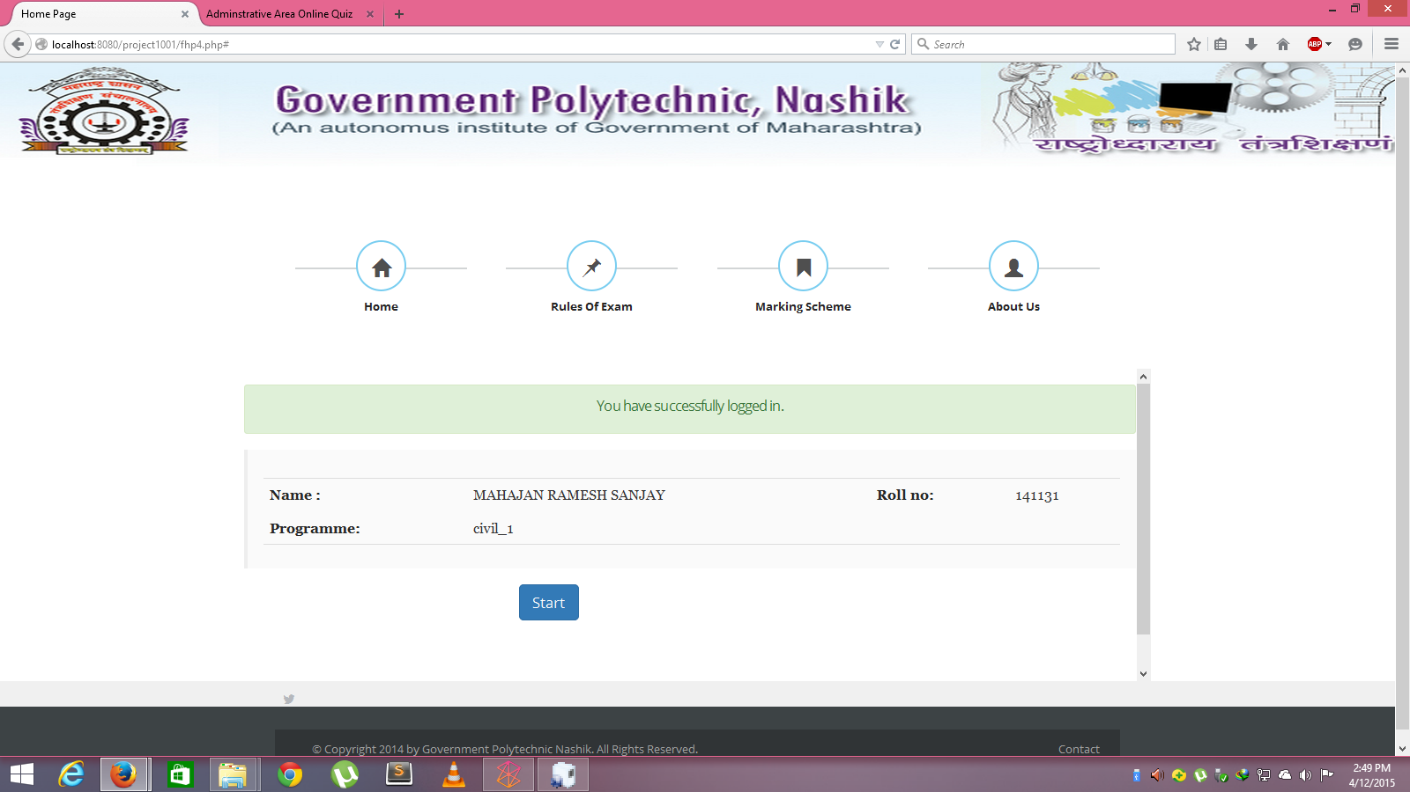

1. Actual TEST PAPER VIEW

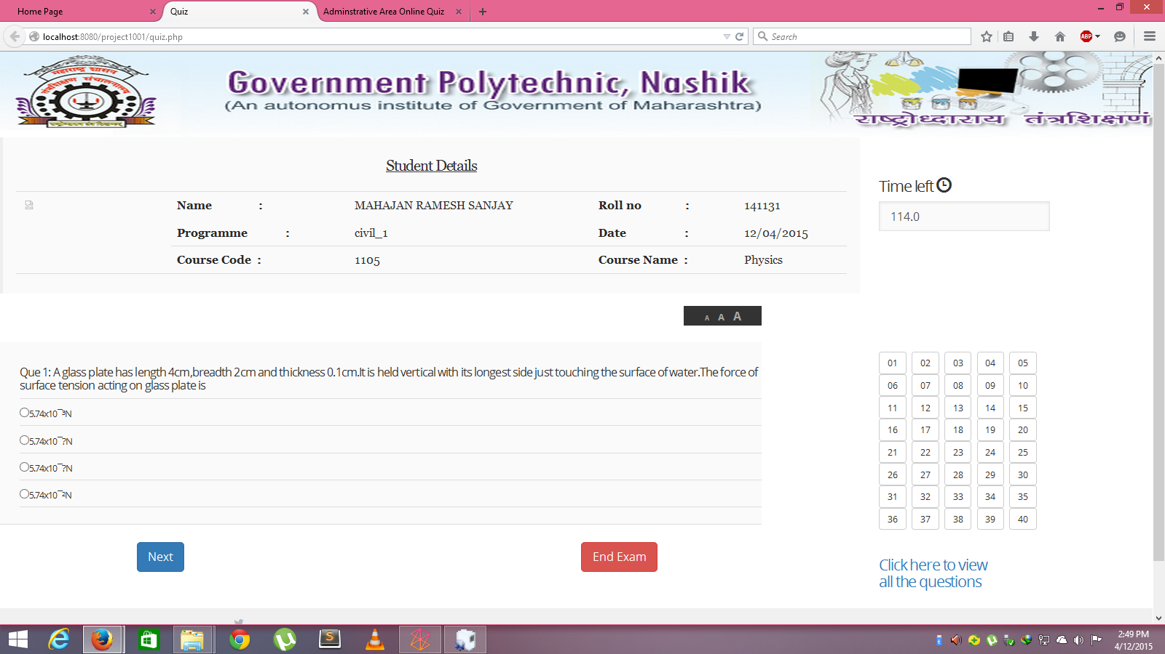

1. After clicking on “END EXAM BUTTON”

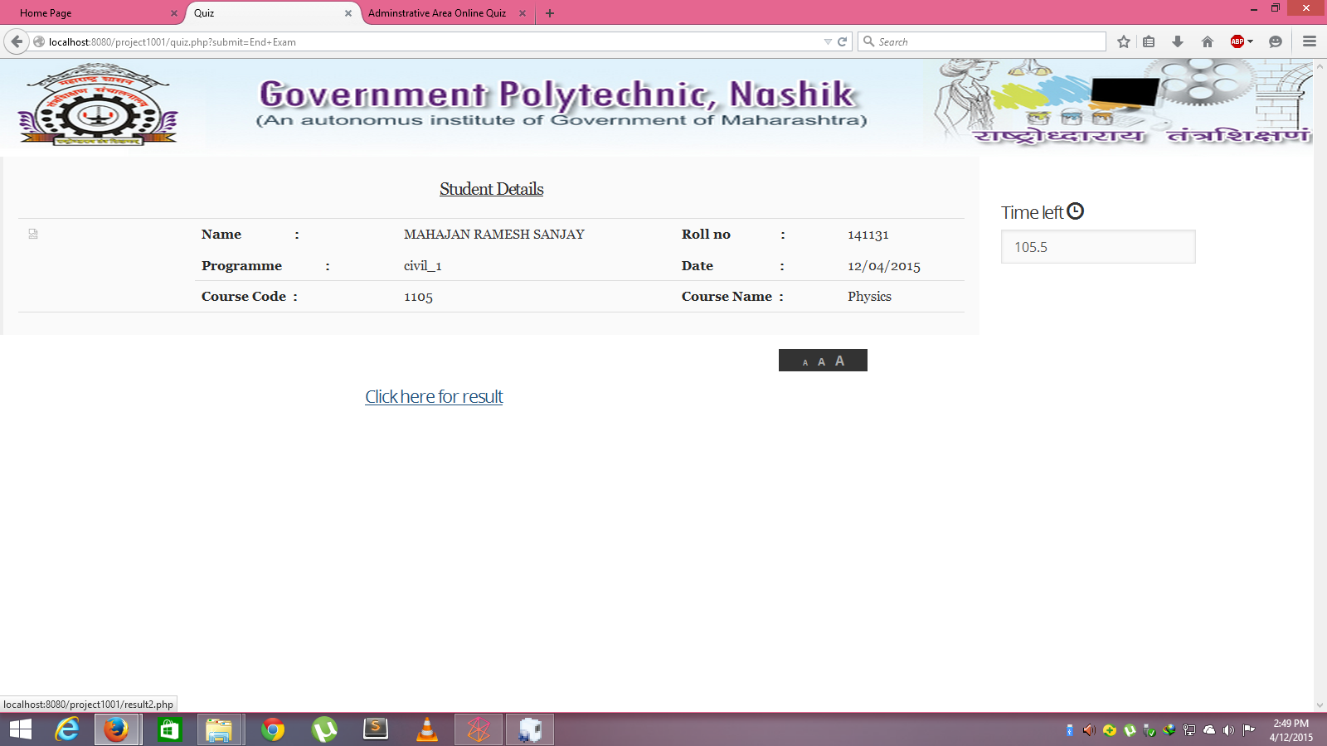

1. Result page view at Candidate’s End

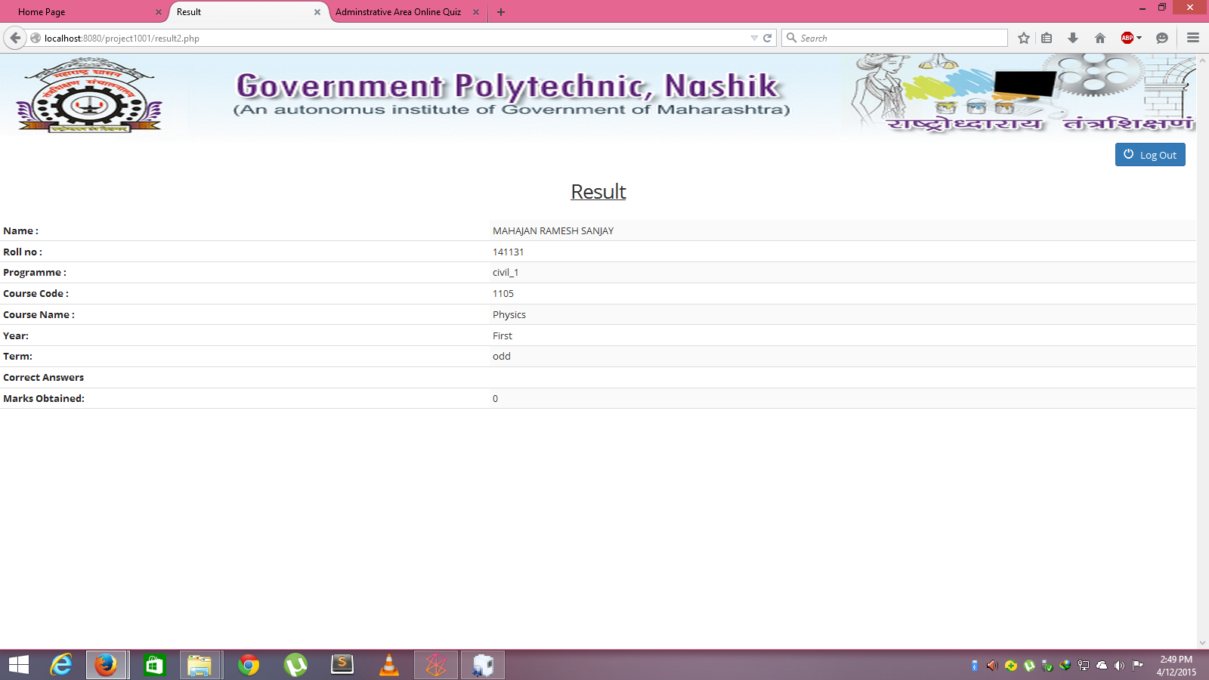

1. On clicking SIGN OUT Button

